A WEB-BASED PATIENT PROFILING SYSTEM

**JUNE NDANU MWOLOLO**

**Student ID: 095199**

**An Information System Project 1 documentation submitted to the Faculty of Information Technology in partial fulfilment of the requirements for the award of the Bachelor’s Degree in Business Information Technology of   
Strathmore University**

**Faculty of Information Technology  
Strathmore University  
Nairobi, Kenya**

**September 2017**

# Declaration

I declare that this work has not been previously submitted and approved for the award of a Bachelor’s degree by this or any other University. To the best of my knowledge and belief, the documentation contains no material previously published or written by another person except where due reference is made in the documentation itself.

Student’s signature:

………………………………….………….. [*Signature*]

………………………………….………….. [*Date*]

**Approval**

The Information System Project 1 documentation of June Ndanu Mwololo was reviewed and approved *(for examination)* by:

Supervisor’s signature:

………………………………….………….. [*Signature*]

………………………………….………….. [*Date*]

# Abstract

This research seeks to find a solution for the healthcare sector in terms of having a patient profiling system. The main problem in the healthcare sector is that patient medical history records cannot be found in one central place as with every visit the same background questions are asked. This project proposed to develop a system that will help minimize the question asking during every visit by enabling a patient to have a single medical for each patient. Users of the system will have usernames and passwords that will enable access to the system. The development methodology to be implemented is the V-shaped model. this is because it allows a sequential approach to developing and testing of the system. System testing will involve ensuring each module works as required both individually and after integration. Also, the processes will be tested to ensure that from logging in to logging out the flow of events is simple.

**Table of Contents**

Declaration ii

Abstract iii

List of Figures vi

Acknowledgements vii

Chapter 1: Introduction 1

1.1 Background 1

1.2 Problem Statement 1

1.3 Aim 2

1.4 Specific Objectives 2

1.5 Justification 2

1.6 Scope and Limitations 2

Chapter 2: Literature Review 4

2.1 Introduction 4

2.2 Record keeping 4

2.3 Challenges facing healthcare sectors 4

2.3.1 Potential benefits of Electronic record keeping 6

2.4 Previous attempts to solve the problem 6

2.5 Failure of existing attempts 6

2.6 What the project proposes to do 7

Chapter 3: Methodology 9

3.1 Introduction 9

3.2 Software Methodology 9

3.3 Development life cycle 9

3.3.1 Advantages 11

3.3.2 Disadvantages 11

3.4 Requirements Discovery 11

3.5 Design 12

3.6 Development Tools 13

Chapter 4. System documentation 14

4.1 System Overview 14

4.2 Functional requirements 14

4.3 Non-functional requirements 15

4.4 Data Flow Diagrams (DFD) 16

4.4.1 Level 0 Data Flow Diagram 16

4.4.2 Level 1 Data Flow Diagram 17

4.5 Flow Chart 18

4.6 Entity Relationship Diagram 19

4.7 Database Schema 20

4.8 GUI designs of forms and reports 21

5.1 Overview 24

5.2 Test case 25

5.3 Test environment 26

5.4 Test results 27

Chapter 6: Conclusion and Recommendations 28

References 29

Appendix A: Timeline of Activities 31

Appendix B: TurnItIn Similarity Index 32

Appendix C: User manual 33

# List of Figures

Figure 1.1: Example of an electronic Health Record Report 8

Figure 2.1: Software Development Lifecycle (SDLC (Jones, 2016)………………….9

Figure 3.1: V-shaped Model in SDLC (Kongsumran, 2016)………………………...11

Figure 2: Level 0 Data Flow Diagram of general processes 16

Figure 3: Level 1 Data Flow Diagram of adding a new patient 17

Figure 4: Log In flow chart 18

Figure 5: Entity relationship diagram 19

Figure 6: Database Schema 20

Figure 7: Graphical User Interface for patient medical report 21

Figure 8: Graphical User Interface 22

# Acknowledgements

I would like to offer my heartfelt gratitude to God who has been my strength and guide all through.

Secondly, I would like to express my gratitude to my supervisor, Benjamin Mundama for the guidance, advice and continuous encouragement he has offered me at every step of the way, the project coordinator Allan Omondi for introducing me to the world of Information Technology and the knowledge related to Information Systems project he impacted on me.

Lastly, my gratitude goes to my fellow classmates for their suggestions and constant challenges in a positive way that made me think outside the box, and for their support during the project development phase.

# Introduction

## Background

Healthcare is the gradual improvement of health through the process of diagnosis, treatment and prevention of infectious diseases and other impairments in the human body both physical and mental- which is done by health professionals. Healthcare remains to be the most fundamental human requirement globally. Healthcare access varies from rural to urban areas because of influence from economic social and political factors however, to receive medical care some information must be shared. Health care centres such as public hospitals have an occupancy rate of 80% (BioMed Central, 2003).

With the recent increase in population the percentage is up to 94% which means that everyone has sought medical help in his/her lifetime. In addition to which personal information is recorded with every visit made to a healthcare facility. Hospitals and clinics in the rural areas mostly use paper based records to store patient information including some healthcare centres in urban areas however, with recent technological advancement in the 21st century (Kumar & Lee, 2011) .

In Kenya, Kenyatta National Hospital is ranked as the primary referral hospital with a daily attendance record of more than 2,000 inpatient and 1,500 outpatient visits according to (Ouko, 2012, November) with 60% of the number suffering from common illnesses with the other 40% seeking specialized healthcare. With such a high attendance record, having to answer the same questions of medical past more than once becomes time consuming.

## Problem Statement

The main problem that arises from having a patient with different medical records history is that, when it comes to analysing whether he/she has been treated and cleared of the illnesses is hard. As such, patient details such as allergic reactions, previous medications, and or future treatments are not recorded on one central form rather different forms based on each patient visit and the information he/she is willing to expose. As such having a clear background on the patient’s medical history is not easy which makes progress difficult.

## Aim

This project is targeted towards developing a web based system that allows the record keeping of a patients’ medical visit from the day of registration (ideally being birth) to the day of death. As such previous medical and future appointments will be in one form on a single platform and on retrieval, all prior treatments can be viewed and updated by the doctor.

## Specific Objectives

1. To investigate the advancement of Electronic Health Records.
2. To analyse the benefits of Electronic Health Records(EHR’s).
3. To develop a patient profiling system.
4. To test the patient profiling information system.

## Justification

The health care industry stands to benefit from this project because the proposed project is aimed at ensuring that by having a patient history form that provides information of prior treatments that are terminated or ongoing with other hereditary illnesses, treatment will be made easier. This is because a medical practitioner will have all the information required to understand a patient’s history without having to ask questions that require a detailed history rather the questions to be asked will be to clarify what is already recorded.

Patients being the main stakeholders stand to benefit from this project in that, with every visit to a healthcare facility they are assured that a clear background of their health progress can be easily accessed without having to answer some questions with every hospital visit and when it comes to being referred to other doctors, the transfer process does not require any repeat testing and documentation.

## Scope and Limitations

The project is expected to have a fully functional database and user interface that meets the expected benefits of an Electronic Health Record keeping system. The system should allow a health practitioner to enter patient details, and with every patient visit information will be updated on the patient profile.

The system should also provide a way in which other healthcare facilities can access the medical record of a patient seeking help from another institution based on a unique number generated for each patient. This will be beneficial instead of having several different reports for a single patient as it allows a health practitioner to be up to date with a patient’s history prior to the actual visit.

The limitation of research time is expected to be faced by the researcher as it will not be possible to visit all rural based healthcare facilities. However, this will be compensated by gathering information from health practitioners who have prior knowledge of how patient records are stored in the area. This also applies to government, private and city based healthcare facilities that are not within reach.

The other expected limitation is withholding of information by healthcare facilities and patients themselves. In relation to healthcare facilities, the information dealt with is sensitive in nature as such, gathering accurate information by the researcher will not be easy.

# Literature Review

## Introduction

This chapter provides a detailed overview of the material used during the study. It will provide a comparison of the systems and technique currently in use by the healthcare sectors in developing counties. An understanding of what many healthcare facilities face while using paper based record keeping are also highlighted in the introduction.

## Record keeping

Record keeping can be summarized as the maintenance of a person’s activities by recording and organizing documents, files and personal information in relation to the business (Press, Cambridge University, 2017). in relation to healthcare, record keeping involves detailed patient details, ailments, medications and doctors who provided diagnosis and treatments for future reference and report writing.

Before technological advancement and the need for National Hospital Insurance Fund(NHIF) mandatory involvement in patient healthcare, information was recorded on paper.

## Challenges facing healthcare sectors

Because of having to record information on paper, healthcare facilities face many challenges during their operations. Some of the problems include:

1. Disintegration due to paper-based records.

This is whereby a patient has multiple encounters with different doctors in the same/different institution whereby, between each visit there is minute exchange of information which can provide a detailed report of the patient’s medical history. As such information that can prove crucial when deductions are made is lost. According to (ArtiModi, 2013) fragmentation of information for patient x occurs when:

1) The patient is not able to communicate adequately what the doctor(provider) wants

2)The doctor(provider) has limited access to information collected by other providers

3)The provider dealing with the patient is not able to access written information/ genuine health information that can help with the dissemination of an appropriate treatment plan for the patient.

1. Accessibility of the medical information

Considering medical information is stored on paper, this means that only one medical practitioner at a time can access the information of the patient as the paper can be at only one place at a time (ArtiModi, 2013). In addition to which for an active patient updating the paper becomes difficult as the patient moves around with the information besides having the paper lost or misplaced during movement from one healthcare to another. With each subsequent delay of access, treatment, transferral and billing of the patient can have a negative impact on the patient.

1. Human related errors

The staff responsible for writing patient reports must carry out manual reviews of the data fields that have been stored. As this task is labour intensive, the probability of mistakes happening is very high. Time is also a factor that can lead to inaccuracies as delivery from one facility to another is expected. According to (ArtiModi, 2013) if the information regarding the patient is not readily available, medical errors might occur as the staff responsible for providing a detailed report will have to work twice as fast to provide the necessary information needed.

1. Cost of paper based records

The cost of paper records being described here is not just the cost of the actual paper but all related costs. The costs include:

duplication cost- which arises when a copy of the medical information for the patient is needed.

Wages and salaries of hired staff. This additional cost is from the extra personnel hired to work with creation, filing, duplication and distribution of the medical records to the concerned people.

Storage costs in which the space used could be used for a different purpose. The medical records need to be protected from factors such as water, fire and mishandling by unauthorized staff.

Replacement cost. This is incurred because of either mishandling or loss of the original document by either the staff or patient. as such some medical procedures might demand repeat testing which might complicate the health condition of the patient further. To have the valuable information replaced, valuable resources such as time, staff and equipment are used which could be used to help other patients (ArtiModi, 2013).

1. Quality of paper records

Quality involves the actual document which has its own limitations. The handling of the document from one person to another may result to tear and wear or staining. The ink used to fill in the report also degrades with time due to fading. Natural disaster such as fire or water can also damage the information recorded.

### Potential benefits of Electronic record keeping

Need for data integration. Besides having information relating to patient visits in a hospital, an Electronic Health Record can have its information combined with other health organizations such as National Health Insurance Fund(NHIF) which caters for insurance policies. Also, data mining concept can be applied on electronic heath records which use a software technology (Hoyt, 2012).

Need for coordinated care for the patient. Hospitals offer both inpatient and outpatient services, with the help of EHR’s in relation to a patient using both inpatient and outpatient services, related information can be easily shared and accessed by both ends. The patient can have more than one physician at a time in which common information needs to readily available to all of them to ensure efficient and standard patient care.

Potential financial savings. With the adoption of an HER system, the need for having fax machines, mails or clerks to perform an audit of the medical records. In addition to which labour costs will be reduced which can be used in other sectors of the healthcare facility.

## Previous attempts to solve the problem

In relation to solving the shortcomings of paper based record keeping, many systems have been developed to help in record keeping of medical information such as Connect Med and Hello Doctor which attempt to reduce paper based record keeping. However, the problem of different patient history reports has not yet been put into consideration.

## Failure of existing attempts

With previous attempts to solving the problem of having different patient history records, the systems only factored in the aspect of electronic health records but did not consider the possibility of having a single patient history report for a single patient rather than having to write a new report for each visit. The systems in place can generate reports for a visit and not all visits from when the patient was first registered in the system to date (Mwololo, 2017).

## What the project proposes to do

The project proposes to come up with a system that maintains a patient’s medical history on a centralized location. This research aims to find the most suitable way healthcare facilities can have a single medical history report for each patient to enable easy assessment of a patient’s progress. In addition to this, the system will have an instinctive user interface to as to minimise the risk of human error in that users of the system can be able to enter and retrieve information from the system with ease.

According to (Heath, 2016)With the improvement of patient safety by healthcare centres the number of deaths can be minimized by close to 50%, in relation to a research conducted in John Hopkins Medicine by the Armstrong Institute for Patient Safety and Quality. The proposed system aims at minimizing safety related deaths because of mismatched information by providing general access to patient information in any hospital. This means that a patient can be easily referred to any hospital and his/her details retrieved from the database using a special number that will be generated and assigned to the patient.

The proposed system is expected to generate reports that provide a summary of:

1. The patient’s medical history form when he/she was first registered (the assumption being at birth).
2. Prior treatments that have been completed and those that are currently ongoing.
3. Future meetings/ doctor sessions.

A screenshot of a cell phone

Description generated with very high confidence

Figure 1.1: Example of an electronic Health Record Report

# Methodology

## Introduction

This chapter provides an overview of the software development process to be used to achieve the objectives set in chapter one and implement the review explained in chapter two. It will provide a detailed analysis on the software development methodology to be used in developing the system.

## Software Methodology

According to (Whitten & Bentley, 2007)system development methodology is described as a standardized process that includes deliverables, methods tools and techniques to be used in development of information systems. In relation to this project, the methodology to be applied will be Structured System Analysis and Design

## Development life cycle

The Software Development Life Cycle to be used in marking the phases of the project will be based on the seven-step SDLC (Jones, 2016)as shown below.

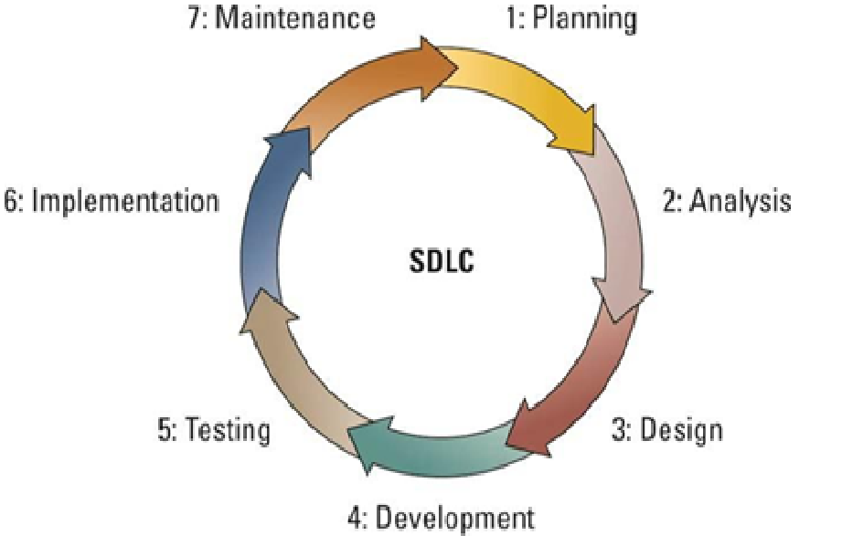

Figure 3.1: Software Development Lifecycle (SDLC (Jones, 2016)

The first stage is the planning phase which involves the primary activities; identification, selection and definition of the system to be developed. This is done based on the goals and of the organization to achieve the business goals. The project scope must be considered to: firstly, to answer the question, “Is the project worth Undertaking?” and secondly, establish project boundaries, size, vision and limitations in relation to the set budget schedule (Whitten & Bentley, 2007).

The second stage is the analysis phase that requires stakeholder involvement together with the developers in documentation of the proposed system. The developers gather information that will necessitate successful end-user requirements implementation.

The third stage is basically coming up with a blueprint design of the proposed system. This shifts the point of view to a technical perspective by considering the documentation and transforming it to a pictorial representation using Case tools.

The development phase involves building the actual system based on the information represented in the design phase. The technical aspects of the system are developed in addition to installing the necessary software for end user navigation.

System testing helps in verifying that the system performs as expected by the users and all the business requirements explained are met. The method of testing the system is also explained in addition to a thorough evaluation of the expected results against what the system outputs. Only if the system performs as expected an it be implemented which comes as the next step.

Based on the stakeholders in the project/ end users, the project is distributed to the intended people for immediate use and implementation. As the system is deployed, a detailed documentation accompanies it to ensure that the expected users have the knowledge to use the system. Based on the end user, this phase can be approached through various routes such as pilot, parallel or the plunged implementation (Jones, 2016).

The last stage is the maintenance stage which involves frequent updates, monitoring and support of the new system to ensure that the business goals and objectives are met. In relation to the business environment, the system is advanced to ensure that it meets all the changes.

Based on the brief explanation, the SDLC to be used will be the V-shaped model (two step verification).in this method, the project execution is done in a sequential manner that incorporates the 7-step SDLC model. The technique involves subsequent testing of each unit before proceeding to the next step. The main reason this technique is better of than waterfall is that it allows testing at each stage before proceeding.

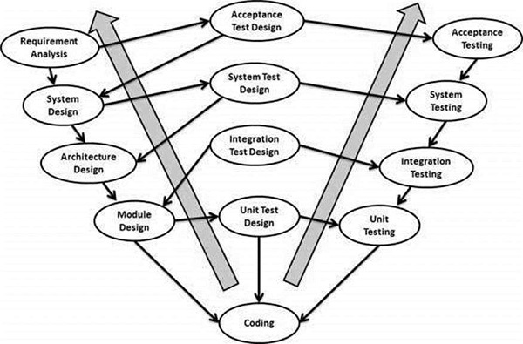

Figure 3.2: V-shaped Model in SDLC (Kongsumran, 2016)

### Advantages

1. It works well with small scale projects with easy to understand requirements.
2. Suitable when resources with the required technical expertise are available.
3. Simple to understand and implement.
4. Easy detection of errors and defects in the system during the early stages which helps in avoiding last minute popups.
5. Saves time as compared to the waterfall method.

### Disadvantages

1. Midway changes indicate changes in the testing and documentation stages which leads to time wastage.
2. It is inflexible and rigid thus additional of subsequent information becomes tiresome.

## Requirements Discovery

Having in place effective requirements finding techniques forms a crucial part in the development of an information system based project (Whitten & Bentley, 2007). Requirements discovery/analysis is simply the techniques/processes implemented to find out problems and solutions for the users. The man types of requirements are the functional and non-functional requirements. The functional requirements according to (Whitten & Bentley, 2007) are basically what the system must do while the non-functional requirements explain what the system must have. The main fact-finding techniques to be used are sampling existing reports and documentation, research and visiting of the hospitals within reach and use of interviews.

Sampling of existing reports and documentation will help in ensuring that the facts obtained are accurate as compared to getting information from people. Some of the documentations to be used include: reports, previous requests for projects and documentations for systems in use in addition to expectations from end users.

Research and site visits will enable me not only in gathering first-hand information but also in knowing healthcare centres that are being faced by similar challenges and those who are willing to share valuable information. Research will help in identifying some of the previous attempts at solving the problem identified in healthcare centres.

With interviews being the most effective fact-finding technique, this method will assist me not only in finding information but also in verification, clarification, requirements identification and acquiring opinions and ideas that will help in coming up with a system that meets market demands.

## Design

Based on the Structured System Analysis and Design (SSAD) approach to be used, the main diagrams to be drawn will be:

1. L0 and L1 Data Flow diagrams.

This will be of benefit in determining the initial project scope. The model will be mandatory in depicting how the proposed processed in the healthcare record system will interact with the user inputs, output and data information.

1. Enhanced Entity Relationship Diagrams

This model will assist in providing a detailed overview of the structure of the data that is stored in the system without focusing on the processed involved.

1. Database Schema

The database schema will be to provide an overview of the tables, constraints and attributes to be put into consideration during the development of the record keeping information system.

1. GUI design of forms and reports using mockups

This design implementation will be to provide an overview of how the system output is expected; including the details to be processed and the information input required.

## Development Tools

The Integrated Development Environment the project intends to apply is Adobe Dreamweaver with PHP, HTML, JavaScript and CSS programming languages. The DBMS to be used will be MySQL database. This is because the development tool is open source, easy to use and understand. It is user friendly and makes debugging and upgrades easy.

The testing method to be used will be system testing, applying functional testing as the main testing technique. The main reason for choosing this technique is that it helps in testing whether the system is performing according to the specifications and the documentation standards. Both positive functional testing and negative functional testing will be applied to monitor the system’s response to invalid and valid input. Microsoft Visio and Microsoft office project tools will be used in the development of the project in drawing Data Flow Diagrams and the Gantt chart.

The system will be executed on a web-based platform. The reason that makes this platform more suitable than a mobile-based or desktop-based is that it can be accessed from anywhere. With desktop systems, installation must be done in order for the system to work.

# Chapter 4. System documentation

## System Overview

The system encompasses all the activities that are associated with the record keeping of patient details in a health facility. The users will be able to access the database from their laptops using web browsers, information will be accessed from any healthcare facility and not a fixed location.

## Functional requirements

|  |  |
| --- | --- |
| ID | Description |
| FR1 | The system should provide real-time access to a patient’s health information whenever it is needed. This will include doctor’s notes and letters. |
| FR2 | The system allows patients to check their medical records with the aid of a doctor, administrator or a nurse. |
| FR3 | The system administrator manages patient records and the system itself. |
| FR4 | The system should only by users who are already added into the system and have the required credentials to access the system. |
| FR5 | The system should be able to generate reports that will help in the evaluation of a patient’s progress across disciplines such as disease management and patient care plans. |

## Non-functional requirements

|  |  |  |
| --- | --- | --- |
| ID | CATEGORY | DESCRIPTION |
| NFRQ1 | Confidentiality | The system should be able to maintain data security in that patient records should only be accessed by the authorized personnel as patient information is sensitive in nature. |
| NFRQ2 | Reliability | The system should be able to meet user requirements always regardless of when and the time. Downtime should not affect patient access to their medical records |
| NFRQ3 | Integrity | The system should be able to generate honest reports based on information that has been entered. |
| NFRQ4 | Performance | The system should be able to perform under all possible situations such as high number of patients requesting treatment at once |
| NFRQ5 | Compatibility | The system should be able to work across various platforms such as desktop or laptop using different operating systems and web browsers |
|  |  |  |
|  |  |  |

## Data Flow Diagrams (DFD)

### Level 0 Data Flow Diagram



Figure 4.1: Level 0 Data Flow Diagram of general processes

### 4.4.2 Level 1 Data Flow Diagram



Figure 4.2: Level 1 Data Flow Diagram of adding a new patient

## Flow Chart

A close up of a logo

Description generated with very high confidence

Figure 4.3: Log In flow chart

## Entity Relationship Diagram

This is a high-level data model used in database design whereby all entities and relationships are identified so ass to gain an understanding of the nature of the data and its flow within an enterprise.



Figure 4.4: Entity relationship diagram

## Database Schema

A screenshot of a cell phone

Description generated with high confidence

Figure 4.5: Database Schema

## GUI designs of forms and reports

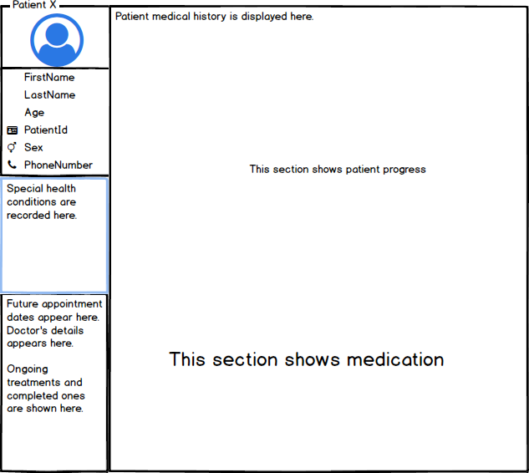

Figure 4.6: Graphical User Interface for patient medical report

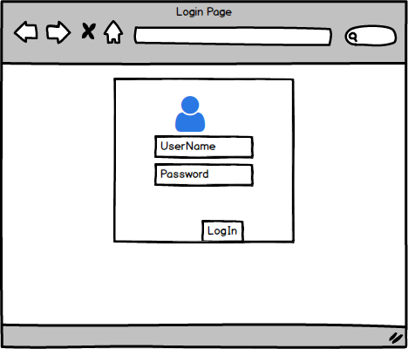

Figure 4.7: Graphical User Interface for login page

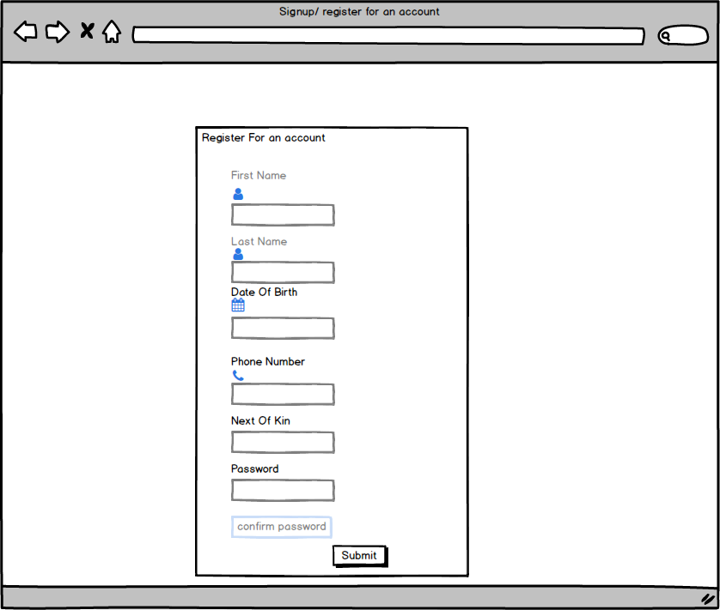

Figure 4.8: Graphical User Interface for registration page

Chapter 5. Implementation and testing

## Overview

This chapter intends to provide an overview of the steps taken to ensure that the system is fully functional, meets the specified requirements and functions as expected.

## Test case

|  |  |  |  |  |  |
| --- | --- | --- | --- | --- | --- |
| Test ID | Related requirements | Inspection check | Pre-condition | Test data | Priority |
| T1 | FR1 | Does the system allow users to access patient medical history whenever needed? | The users have to login to the system to access information | Session data for the current user and information from the database. | High priority. |
| T2 | FR2 | Does the system allow already registered patients to view their medical history? | The patient can view his/her medical history with the help of a registered user. | Information in the database. | High priority. |
| T3 | FR3 | is the administrator able to register new patients into the system and monitor system activities? | The administrator should be logged into the system. | Session data for the administrator. | High priority. |
| T4 | FR4 | Is the system only accessible to registered users or can anyone access the system? | The users of the system must be registered before being granted permission to view. | Information of the users that exists in the database. | High priority. |
| T5 | FR5 | Is the system able to generate reports of patients’ profile and medical history? | The system should be able to display a patients’ medical report on the browser for viewing. | Information stored in the database. | High priority. |

## Test environment

The system uses a web browser to run. As the information is stored on a local server, external resources are not required by the system. For one to be able to access the system, they should have access to the internet and an available network.

## Test results

|  |  |  |  |  |
| --- | --- | --- | --- | --- |
| **Test ID** | **Expected results** | **Actual results** | **Status** | **Remarks** |
| **T1** | the system should allow registered users to access the system | Users can access patient medical history | Pass | Accessing patient records was fast once a user is logged into the system. |
| **T2** | Registered patients should be able to login and view their records | A registered patient can be able to login and view their results | Pass | Once a patient is in the system, he/she can view their medical history. |
| **T3** | The administrator should be able to add new patients in the system | only the administrators can add new patients | Pass | A logged in administrator can add new patients |
| **T4** | The system should only be accessed by registered users and patients only. | without the correct credentials, one cannot access the system. | Pass | Registered users are able to access the system and view records. |
| **T5** | the system should enable report functionality of a patients’ medical history | **Ctrl+p** shortcut enables one to print the medical report, only if there are no buttons on the report | Pass |  |

# Chapter 6: Conclusion and Recommendations

**6.1 Conclusion**

With the recent trends in the healthcare centre, patient profiling in terms of having one medical record per patient can be deemed vital. The development process as such there is need to have a system that entails all medical visits of a patient and a way to view the records. The system provides a platform where hospital administrators, doctors and/ nurses can register patients into the system and key in each hospital visit both check-ups and treatment, after which the system displays all the records entered. The system comes in handy in that, a single patient has a single medical profile in which all the information about him/ her is stored there instead of having each visit recorded on a separate form.

**6.2 Recommendations**

# References

ArtiModi. (2013, April 01). *Medical records 5 top disadvantges of manual medical records*. Retrieved from Med League: http://www.medleague.com/5-top-disadvantages-of-manual-medical-records-emr-expert/

*biggest health-care breaches 2017*. (2017, september 5). Retrieved from HealthcateITnews.com: http://www.healthcareitnews.com/slideshow/biggest-healthcare-breaches-2017-so-far?page=1

*BioMed Central.* (2003, february 26). Retrieved from World Health Organization: http://www.who.int/choice/country/ken/cost/en/

Garruba, T. (2014, November 10). Retrieved from healthcareITnews: http://www.healthcareitnews.com/news/5-ways-health-data-breaches-are-far-worse-financial-ones

Heath, S. (2016, April 26). *News*. Retrieved from HealthIT Analytics: https://healthitanalytics.com/news/patient-safety-improvements-could-cut-avoidable-deaths-by-50

Hoyt, D. R. (2012). Health Informatics: A Practical Guide. In D. R. Hoyt, *Health Informatics: A practical Guide* (pp. 76-109). West Florida: Infomatics Education. Retrieved from Practise Fusion.

Jones, S. (2016, October 29). *Dissertations Blog.* Retrieved from Study-Aids: http://study-aids.co.uk/dissertation-blog/system-development-life-cycle-sdlc/

Kongsumran, S. (2016, april 15). *blog*. Retrieved from kmutt: http://www.cs.sit.kmutt.ac.th/blog/?p=537

Kumar, P., & Lee, H.-j. (2011, december 22). *articles:NCBI*. Retrieved from National Centre for Biotechnology Information(NCBI): https://www.ncbi.nlm.nih.gov/pmc/articles/PMC3279202/

Mwololo, P. (2017, September 16). Current electronic record systems. (J. Ndanu, Interviewer)

Ouko, E. R. (2012, November). *performance Audit report of the auditor general specialized healthcare delivery at Kenyatta National Hospital.* Nairobi: Auditor General.

Press, Cambridge University. (2017). *Cambridge English dictionary.* Retrieved from Cambridge Dictionary: http://dictionary.cambridge.org/dictionary/english/record-keeping

Whitten, & Bentley, L. D. (2007). *Systems Analysis and Design Methods.* New York: McGraw-Hill/ Irwin.

# Appendix A: Timeline of Activities

A screenshot of a computer

Description generated with very high confidence

# Appendix B: TurnItIn Similarity Index

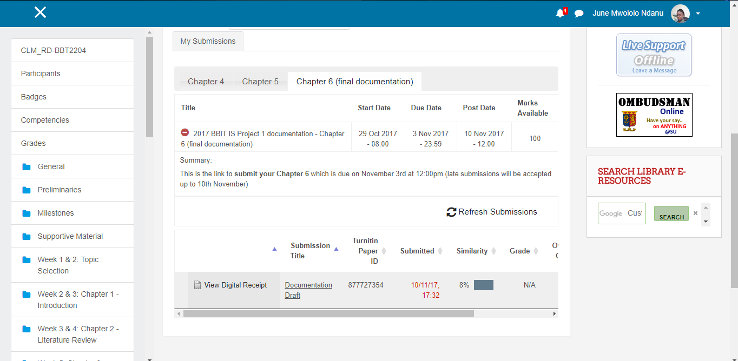

# Appendix C: User manual

**Installation of XAMPP server**

The system must be accessed through a web browser and a local server XAMPP for one to view the records in the database. Below is a step by step guide of how to install the server on a machine.

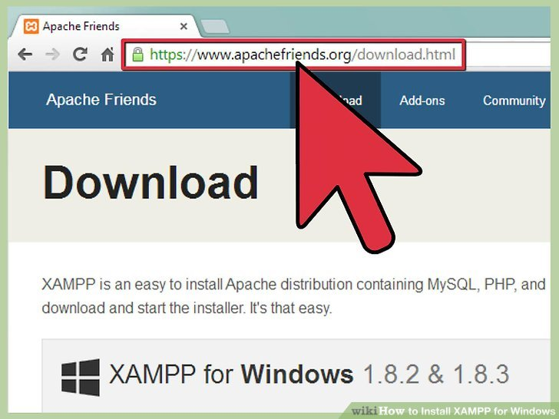

Step 1: Accessing Apachefriends.org (ApacheFriends, n.d.)

Once you have completed step 1, the display will be various versions of the server based on whether the operating system is Windows, Linux or Mac. In addition to which one can download either 32-bit or 64-bit based on the system. Once you select based on your system specifications, click save to start downloading the setup of the system. Depending on the size and network speed, downloading might take long.

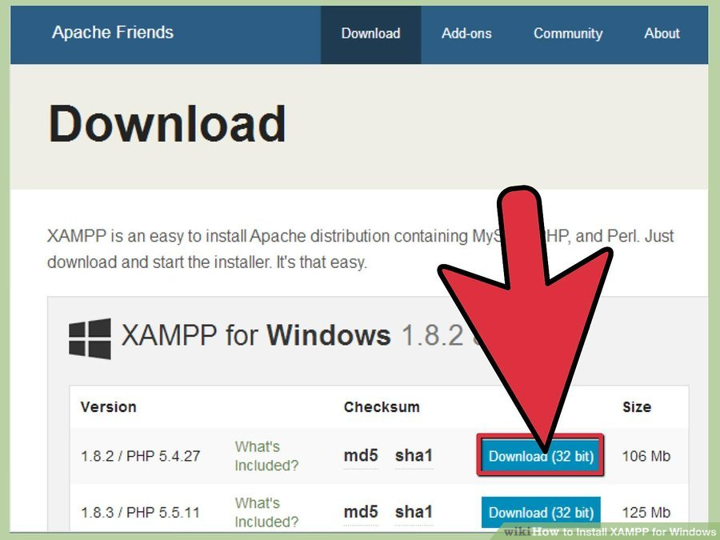

step 2: Downloading the server for windows (ApacheFriends, n.d.)

Once the download is complete, click on the file to initiate the installation process. A window similar to the one below appears in which by default the necessary files have been selected ready for installation. Whenever prompted by a command line, hit enter to accept the defalt settings.

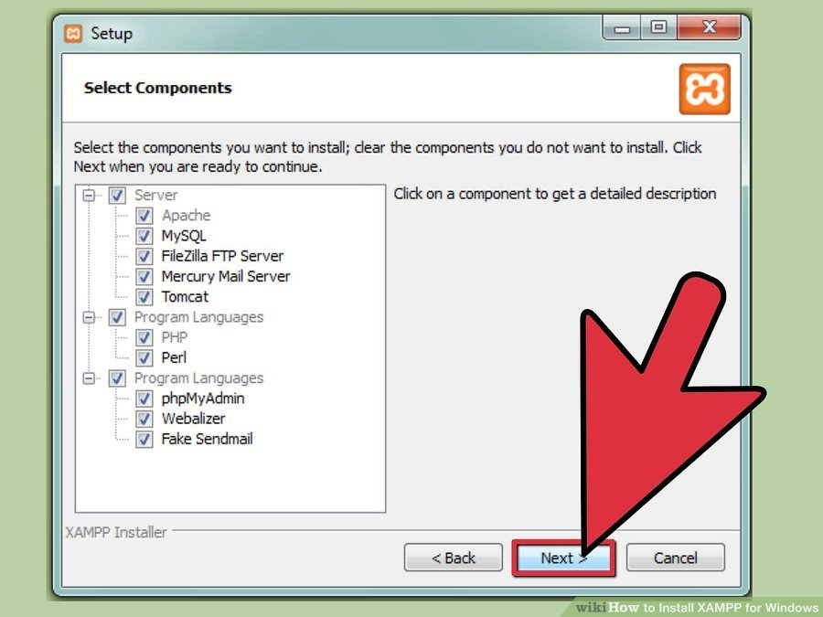

step 3: Starting system installation (ApacheFriends, n.d.)

When the installation is complete, a command prompt shown below appears which enables you to either start the control panel immediately after installation or later. The control panel enables one to start the server whenever needed.

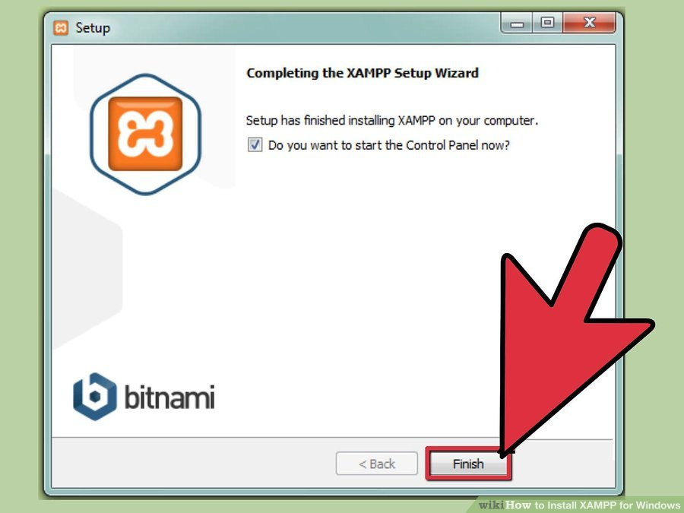

The control panel as shown below appears. To have the server up and running, under the actions tab, select Apache and MySQL.

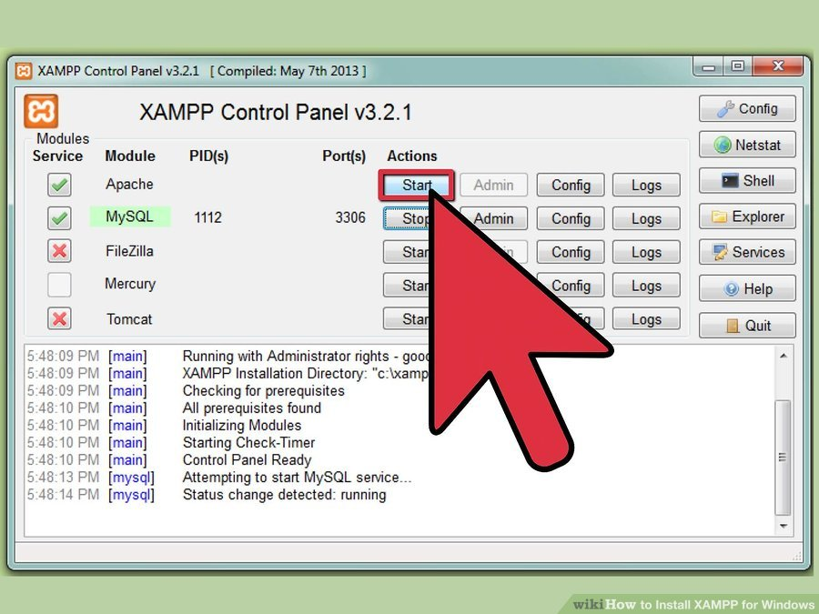

**Installation of the database into XAMPP(localhost)**

Once the server is installed, Apache and MySQL are running, one accesses the host database by typing (<http://localhost/phpmyadmin/>) which opens the page shown below:

A screenshot of a computer

Description generated with very high confidence

Select the import tab which redirects one to the page shown below. Select the choose file tab which allows you to browse where you saved the file with the database dump.

